**Java In Class Assignment**

**This is your ROADMAP for constructing the well-built Object-Oriented Application**

# Your Challenge:

### Learning Outcomes:

1. To experiment with the techniques of constructing a good, solid Object Oriented Application.
2. To put into practice our knowledge constructing communities of OBJECTS by connecting the OBJECTS:
   1. Using Composition
   2. Using Inheritance
3. Remember to make your OBJECTS have:
   1. HIGH COHERSION: ALL methods and fields focused to doing 1 job
   2. LOW COUPLING: Objects have METHODS which are well-structured and easy to connect to different objects

Let’s find out whether Lions or Tigers are stronger

Let’s write an Object-Oriented Application to Model a competition between Lions and Tigers.

Rule 1: Always start by drawing a PICTURE of our System. <http://draw.io>

Instructions:

Create an Algorithm that generates 10 Lions and 10 Tigers.

The Algorithm assigns a Strength level between 1 and 100 to each Feline.

We do competitions between the felines by comparing their strength Levels

Goal: We keep track of how many LION winners and how many TIGER winners we have at the end.

Then we declare the WINNER: Lion or Tiger!

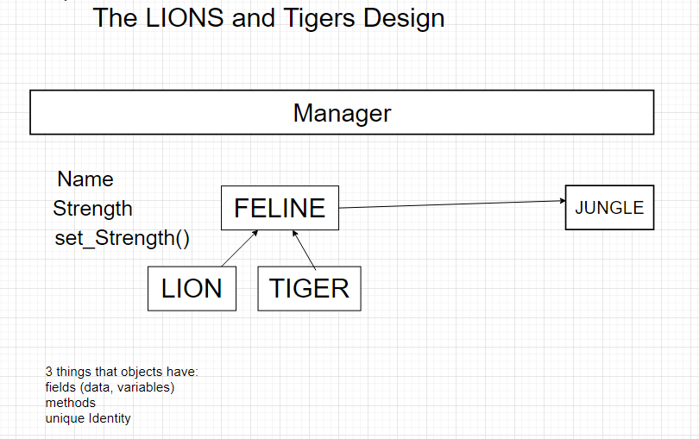

Challenge Number 1:

Write a Class

with a METHOD

Create an OBJECT from that class

invoke the method

Challenge Number 2:

Introduce inheritance and subclassing

Challenge Number 3:

Introduce a Design Pattern called the Factory Method to generate lots of OBJECTS